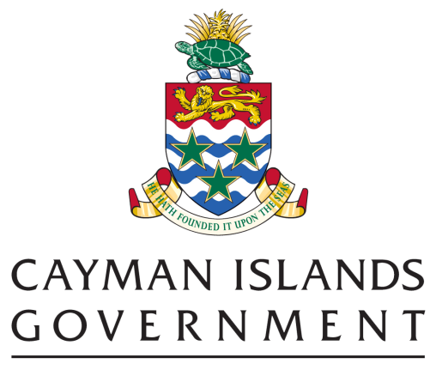

<Title of Investment Proposal>

SINGLE STAGE BUSINESS CASE - LOW VALUE AND RISK ($0 TO $250K VALUE OF PROCUREMENT)

Project Sponsor
Project Manager
Entity

- INTRODUCTION

<State the purpose of the business case and the spend for which approval is being sought.>

- THE CASE FOR CHANGE

<Describe the proposed intervention and the needs you are seeking to satisfy? How does satisfying these needs contribute to CIG/Ministry/Department goals and objectives?>

- OPTIONS ANALYSIS

  - Main options
<Describe the options considered: advantages and disadvantages, and conclusions. Consider the “Do Minimum” option.>

  - Recommended option
<Describe the recommended option: scope and main deliverables, related cost(s), main benefits and risks, and timescales; and why this solution has been selected over other options.>

  - Sources and assumptions
<Describe the sources and assumptions for the evidence base supporting the recommended option, and why approvers should have confidence in the information provided.>
- PROCUREMENT ROUTE

<Describe what you are procuring and how this will be undertaken in accordance with the Procurement Law and any relevant Ministry/Department policies and procedures to deliver value for money.>

3.1 The Inclusion of Micro & Small Business

<Describe the plan, if applicable, to encourage local micro and small businesses (see definition here) to compete for and be competitive in this procurement project>

<Explain if and why the procurement is going to be restricted to local suppliers or opened to international suppliers. Where the project is open to a global market place, describe the risk or impact on local suppliers (micro and small businesses especially) and how that is being mitigated.>

3.2 Related Procurements

<Are there any past or concurrently planned procurements that this project is related to or needs to be compatible with? If so please list them and describe your strategy for ensuring that these procurements complement each other.>

<If this procurement is part of a larger project, provide a breakdown of all anticipated, future procurement projects that this procurement will relate to.>

- FUNDING AND AFFORDABILITY

<Describe how the procurement will be funded and any additional resources required, including any commitments that have already been made to guarantee the funding or other resources required. Summarise the indicative financial implications and sources of funding for the proposed investment over the life of the project using the table below.>
Table 1: Cost and Funding for the Recommended Option
Lifespan |  | Year 1 | Year 2 | Year 3 | Year 4 | Year 5 | Total
Capital Expenditure
1 | Fixed assets
2 | Software
3 | Other Capital item
4 | Total Capital costs (CAPEX)
Operating Expenditure
5 | Personnel
6 | Maintenance
7 | Operating licences etc.
8 | Training
9 | Other Operating costs
10 | Total Operating costs (OPEX)
Total Expenditure
12 | Total Project Costs (CAPEX + OPEX)
Funding
13 | CAPEX funding from Cabinet
14 | OPEX funding from Cabinet
15 | Third party funding (CAPEX if any)
16 | Third party funding (OPEX if any)
17 | Total funding
Affordability Assessment
18 | Shortfall/Overage CAPEX (CAPEX Costs – Total CAPEX Funding)
19 | Shortfall/Overage OPEX (OPEX Costs – Total OPEX Funding)

Revenue Generation
Table 2: Revenue Projections for the Recommended Option
Recommended Option |  | Year 1 | Year 2 | Year 3 | Year 4 | Year 5 | Total
Revenues
1 | Sales and other Revenue

- DELIVERY ARRANGEMENTS

<Describe the arrangements in place for successful delivery of the scheme:
- the governance arrangement (roles and responsibilities and reporting lines);
- the project plan
- project assurance
- benefits delivery
- risk management
- any assistance required from other parts of government or the private sector>

 | Name | Signature | Date
Prepared by:
Reviewed by:
Approved by:

