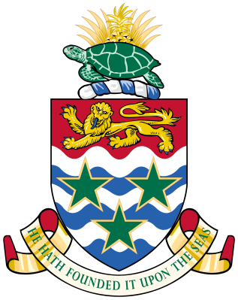
Public Procurement Committee
Direct Award Submission Check List
(For Projects above $250,000)

Public Sector Agency:
Title:

☐ Completed, Signed & Approved Business Case
☐ Completed, Signed & Approved Direct Award Approval and Justification Form, as per template https://www.procure.gov.ky/direct-award-process
☐ Project Specifications, Deliverables & Supporting Vendor Quotation
☐ Signatures on Business Case & Justification Form (inclusive of CO/CEO signature)

Please note that the Direct Award Approval Form, Direct Award Justification Form and Business Case need to be submitted to Shiann Palmer (Shiann.Naulty@gov.ky), Secretary of the Public Procurement Committee, by 8 calendar days before the meeting in which you intend it to be considered. Late submissions are not guaranteed to be considered at the requested meeting but may be slated for the next available meeting.

The scheduled dates for PPC meetings can be found here: https://www.procure.gov.ky/ppc-meetings

