
Public Procurement Committee (PPC)
Direct Award Submission Check List (For Projects above $250,000)

Public Sector Agency:
Project Title:
Initial Submission (Justification Only)
☐ Completed, Signed & Approved Business Case
☐ Completed, Signed Direct Award Justification Form, as per template https://www.procure.gov.ky/direct-award-process – Justification Portion Only
☐ Project Specifications & Deliverables
Final Submission (Seeking Contract Approval)
☐ Completed, Signed & Approved Business Case
☐ Completed Direct Award Justification & Approval Form, as per template https://www.procure.gov.ky/direct-award-process – Full Form
☐ Supporting Vendor Quotation
☐ Vendor Discussions Report (via Bonfire)
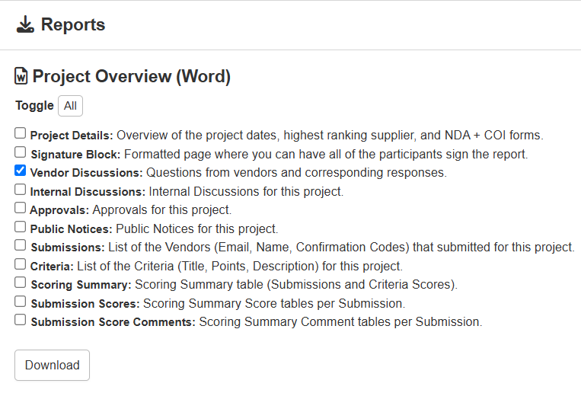
Please note that the requirements for each stage must be submitted to the Secretary of the PPC, Shiann Palmer (Shiann.Naulty@gov.ky) and cc: ppc@gov.ky, by 8 calendar days before the meeting in which you intend it to be considered. Late submissions are not guaranteed to be considered at the requested meeting but may be slated for the next available meeting. The scheduled dates for PPC meetings can be found here: https://www.procure.gov.ky/ppc-meetings

