
Public Procurement Committee (PPC)
Submission Check List
Competitive Procurements
Procurement #:
Public Sector Agency:
Project Name:
Project Budget: | KYD$
Final Contract Price: | KYD$
Contract Term/Duration:
Successful Vendor:
All of the items in the below table must be “met” for a compliant procurement.
Requirement |  | Status |  | Comments
 |  | Met | Not Met | Comments
Pre-Procurement Approval
Business Case developed and Local Impact Assessment Completed
Business Case Reviewed by the EPC
Business Case Approved by the CO/CEO
Pre-Tender Release
Local Industry Impact Statement included in Tender Documents as a rated criteria
Clear Submission Evaluation Criteria
Tender Documents Reviewed & Approved by the EPC
Pre-Tender Closure
Min. 15 Working Day Advertisement Period
Publically published answers to all questions received during the question period without identifying the source.
Post Tender Closure
Bid Evaluation in line with tender documents
Justification for Vendor Eliminations Provided (If Any)
Confirmation of top-ranked vendor’s pricing being within budget
Evaluation Summary and Tender Award Recommendation (ESTAR) report submitted to EPC for review
Evaluation Summary and Tender Award Recommendation (ESTAR) report submitted to PPC for review (>$250k)

In order to secure a spot on the PPC Agenda, the following must be submitted:

☐ Business Case (inclusive of EPC Chair & CO/CEO signature)
☐ Evaluation Summary Report from Bonfire with Reviewer Signatures – Report to only include sections with the BLUE TICKS as seen below.
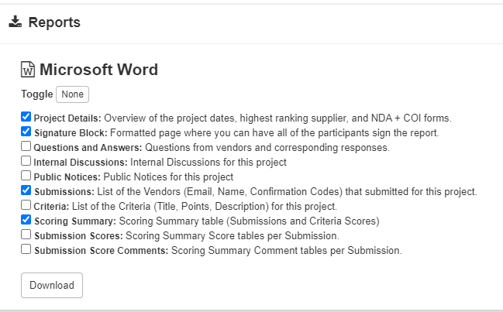
☐ Completed PPC Submission Check List (This Document) - Inclusive of EPC Chair & CO/CEO Signatures
☐ Deliverables & Evaluation Criteria of the Tender Documents (Appendix A in CPO provided tender document templates)
☐ Detailed Pricing Submissions of the 1st and 2nd (if applicable) Highest Ranked Vendors

Please note that the above documents need to be submitted to the Secretary of the Public Procurement Committee, Shiann Palmer (Shiann.Naulty@gov.ky) & ppc@gov.ky, by 8 calendar days before the meeting in which you intend it to be considered. Late submissions are not guaranteed to be considered at the requested meeting but may be slated for the next available meeting.
The scheduled PPC meetings can be found here: https://www.procure.gov.ky/ppc-meetings.

After review of the PPC Submission Checklist & the Evaluation Summary Report for this procurement, the EPC:  - Supports the recommendation of the Evaluation Team as seen in the Evaluation Summary Report presented with this submission to the Public Procurement Committee (PPC).  - Confirms that funding will be made available to support the contract award. | Chairperson of the Entity Procurement Committee (EPC)  Name ______________________  Signature_______________________  Date: ____________________

