

**Contract management toolkit**

|  |  |  |  |
| --- | --- | --- | --- |
| **Contract name:** |  | **Contract number:** |  |
| **Completed by:** |  | **Date completed:** |  |

|  |  |  |
| --- | --- | --- |
| **1** | **Introduction** | **p.2** |
| **2** | **Principles of good contract management** | **p.3** |
| **3** | **Checklist for good contract management** | **p.7** |
| **4** | **Compliance checklist** | **p.9** |
| **Templates:** | | |
| **5** | **Supplier relationship matrix** | **p.10** |
| **6** | **Agenda for supplier managing/review meetings** | **p.11** |
| **7** | **Action/Issues log** | **p.12** |
| **8** | **Terms of reference for supplier strategy meetings** | **p.13** |
| **9** | **Agenda for supplier strategy meetings** | **p.14** |
| **10** | **Risk register** | **p.15** |
| **11** | **Business continuity plan** | **p.17** |
| **12** | **Agreed Key Performance Indicator (KPIs) and KPI tracker** | **p.19** |
| **13** | **Default Recovery Plan** | **p.21** |
| **14** | **Site inspection template** | **p.22** |

**Introduction**

**Why is contract management important?**

Effective contract management is essential, to make sure that the Cayman Islands Government:

* gets the best value for money from suppliers
* delivers good quality and cost effective outcomes for residents, and
* is compliant with legislation in our commercial activities.

The Cayman Islands Government spends hundreds of millions of dollars a year with external suppliers and it is important that we don’t just focus on the *procurement* of those goods, services, works, utilities and supplies but that there is ongoing *management* of the contracts throughout their term. At a basic level, good contract management is about attention to detail. It means understanding what should be delivered, who has responsibility for delivering it and making sure it is delivered to the agreed quality and frequency and for the agreed price. Developing good relationships with suppliers based on trust is another component of effective contract management, and it can be particularly important if any problems arise or if we seek to renegotiate any elements of the contract. This toolkit has been designed to provide the tools to make contract management easier, and to ensure that clear and consistent processes and procedures are in place and agreed with suppliers.

We hope this toolkit is useful and helps you to effectively manage contracts across the Cayman Islands Government, as well as develop productive relationships with your suppliers. If you have any comments or feedback please [contact us](https://www.procure.gov.ky/contact) at the Central Procurement Office (CPO).

**How to use this toolkit**

This toolkit contains: 1) Principles, 2) Checklists & 3) Templates.

The principles set out the vision of what we aim to achieve through good contract management. The checklists, templates and contract management procedures provide the roadmap for how we get there.

These documents have not been designed to be one-size fits all, but should be adapted by service areas as required. The processes required will be relevant to your specific contract, which will vary depending on the size of spend and criticality of the contract. The toolkit will be reviewed and refined periodically. Updates will be provided on the <https://www.procure.gov.ky/> site**.**

**Objectives of good contract management**

The objectives of good contract management are:

* effective service delivery
* efficient contract administration
* productive relationship management
* legislative compliance

In order to achieve our objectives, there are certain principles of good contract management that should be adhered to. The table below explains the principles in more detail with cross references to the templates contained in the toolkit and other support.

**Principles of good contract management**

|  |  |
| --- | --- |
| **Training & Skills – ensuring that contract managers possess the appropriate skills to deliver good value for money** | **Related templates & Support** |
| Staff involved in the managing of contracts should have subject matter expertise along with adequate skills and capability to effectively and efficiently discharge their roles and responsibilities. | Training for all officers who manage CIG contracts. |
| Contracts should be known and understood by all those who are involved in their management. Contract managers should have a good understanding of the terms and conditions and contractual levers such as default procedures. | Default Recovery Plan |
| Contract ownership, management processes and governance mechanisms should be clear with defined roles and responsibilities. | Supplier relationship matrix |
| **Contract Documents – contract documentation is complete, accurate, up to date and proactively managed** | **Related templates & Support** |
| All officers involved in the managing of a contact should have access to a copy of the contract that they are managing. Where the contract is for the use of a computer system, the officers acting as the system administrator should receive a copy of the system’s administrator’s manual. | Bonfire Contract Management Module |
| Contract documents should clearly set out the roles and responsibilities of all parties to the contract. The documents should also be complete and consistent and not contain any ambiguities. | Supplier relationship matrix |
| Service areas should record the details of all contract managing carried out and the results obtained using templates. | Agreed KPIs to be managed and KPI tracker |
| Contract documents should set out what management information is required from all parties, and contract managers should make periodic checks to verify that this is being complied with. | Agendas |
| When the CIG utilises a framework agreement established by a third party it should also enter into a written contract with the supplier. |  |
| When agencies are used to supply staff, these arrangements should be covered by formal, signed contracts. |  |
| Where appropriate, service areas should seek to include liquidated damages, discounts and/or payment by results clauses as part of the contract terms and conditions. These clauses should be enforced, where they are included in the contract. |  |
| All relevant correspondence with the supplier in relation to contract changes should be stored and easily accessible. |  |
| **Data & Key Performance Indicators - the CIG to focus on relevant performance information available at corporate and service level to ensure it is delivering cost effective services** | **Related templates & Support** |
| The contractual service delivery performance should be measured and reported on. Managing returns should be signed, dated and verified as accurate by the returning supplier. Upon receipt, contract officer should also check return, sign, dated and include comments as required. | Agreed KPIs to be managed and KPI tracker |
| KPIs and data should be used efficiently to incentivise good performance. |  |
| Where self-managing is used, the results should be subject to periodic validation checks by service areas to ensure accuracy and that suppliers are delivering. |  |
| Information about contract managing and other contract issues should be stored within each service directorate. Process should be in place to report/escalate underperformance to senior management. |  |
| Analysis of KPI results should include comparisons with previous years and previous months to ascertain whether contract delivery is improving or deteriorating so that appropriate action can be taken. | KPI tracker |
| **Contract Performance – cost effective methods should be adopted to ensure the CIG receives the service that it has paid for** | **Related templates & Support** |
| Management should look at ways of targeting resources to maximise opportunities for effective contract management, such as consolidating contracts in future procurements, minimising the use of consultants and including self-managing by suppliers who are then responsible for reporting the outcomes to the CIG. |  |
| Contract performance should be assessed monthly for tier one suppliers, quarterly for tier two suppliers and at a minimum annually for all other suppliers, using performance information, KPI data and complaints/compliments information. | Agendas; Action/Issues Log; KPI tracker |
| There should be good communication and liaison when more than one functional unit or service area is involved in the management of a contact. Establish internal user groups to aid communication. |  |
| There should be effective complaints procedures for all contracts, and the results should be used as part of the supplier’s performance review. | Agendas |
| Where the level of service does not meet that set out in the contract, remedial action, escalated where necessary, should be taken. | Action/Issues Log |
| Contract managers and owners should negotiate benefits for the CIG - either cost savings or service improvements - in return for granting the supplier an extension to the contract where extension provisions exist. |  |
| **Payments – payments in accordance with agreed contractual provisions** | **Related templates & Support** |
| Suppliers should be reminded to submit payment requests in accordance with the schedules in the contract and these should be thoroughly checked and paid on time. |  |
| **Risks** | **Related templates & Support** |
| Risk registers for tier one contracts must be recorded, periodically reviewed and updated to include the risks and the controls in place to manage them and the officer responsible. | Risk Register |
| All tier two contracts should have completed risk registers which are held by the contract manager. | Risk Register |
| Financial viability checks should be undertaken routinely with a clear procedure in place to manage high and medium risk suppliers. | Procedure for credit check |
| Risk registers should be completed by all suppliers to identify high level risks that could impact on service delivery | Risk Register |
| **Meetings – effective meetings that drive value** | **Related templates & Support** |
| Contract meetings should be held (as a minimum) monthly for tier one contracts, quarterly for tier two contracts, and annually for all other contracts. They should be minuted and any actions arising should have a target completion date and be recorded on an action/issues log that is actively managed | Agendas; Action/Issue Log |
| Contract owners and managers should include periodic site visits/inspections wherever relevant/appropriate as part of the contract managing regime to check on work carried out and services provided. For example, on a construction site, it is important to make site visits to carry out a visual inspection of progress made. Similarly, on a school meals contract it is important to make site visits to check on the cleanliness and hygiene of the kitchen facilities. | Site Inspection Template |
| **Contracts Register – will be complete, accurate and up to date** | **Related templates & Support** |
| All contracts with a value of $10,000 or more should be entered on to the Ministry’s contracts register. Contract managers and owners should periodically check the accuracy of the information held on the contracts register. | Bonfire Contract Management Module |
| All contract documentation should be held on the contracts register so that it is available to the contract owner and contract manager. This will also help to satisfy Cayman Islands Government transparency requirements. |  |
| Expired contracts should be archived from the contracts register. |  |
| **Effective Processes** | **Related templates & Support** |
| Checks should be made (prior to the commencement of the contract and also while it is in place) to ensure that all conditions of contract have been complied with, including check on qualifications and other due diligence. | Compliance checklist |
| Officers responsible for procuring goods and services should ensure they are fully familiar with the contents of the CIG’s procurement regulations and the contract management toolkit, and comply with their content. |  |
| Service areas should manager the expiry dates of their contracts to enable sufficient lead-in time is built into any renewal/retendering. |  |
| Service areas should liaise pro-actively with the Central Procurement Office to ensure best procurement strategy is identified for renewal/retendering and a detailed procurement timetable is developed to ensure service is in place by the desired start date. |  |
| Where contractors have direct access to CIG systems and are responsible for updating progress etc. on the system then Management should manager compliance with this requirement and remind the contractors of the same when this is not being adhered to. |  |

* **Checklist for good contract management**

|  |  |
| --- | --- |
| * **Name of contract:** |  |
| * **Tier assessment (1 or 2):** |  |
| * **Completed by:** |  |
| * **Date completed:** |  |

|  |
| --- |
| **TIER ONE contract:** Contract value at or above $250,000, or contract is providing a service which is business critical and strategic to the running of the Cayman Islands Government. |
| **TIER TWO contract:** Contract value below $250,000 |

|  |  |  |
| --- | --- | --- |
| **TASK** | **TIER ONE CONTRACTS** | **TIER TWO CONTRACTS** |
| Contract manager has had formal education, training or experience in the subject matter related to contract. |  |  |
| Contract documentation is available. |  |  |
| Accurate contract information and documentation is on the contracts register. |  |  |
| Key Performance Indicators (KPIs) are clearly defined (see KPI template) |  |  |
| Managing/review meetings with the supplier are arranged for the coming year, at a minimum:   * Quarterly for tier one contracts * Annually for tier two contracts |  |  |
| There is a standing agenda for each managering/review meeting (see agenda template) |  |  |
| Suppliers produce a report for discussion at the managing/review meetings (see agenda template). |  |  |
| Attendees for the review meetings are agreed with CIG and the supplier (see agenda template) |  |  |
| There is a completed relationship management matrix (see supplier relationship matrix template) |  |  |
| Semi-annual strategy meetings with the supplier are arranged for the coming year |  |  |
| There is a standing agenda for each quarterly stategy meeting (see agenda template) |  |  |
| Attendees for the strategy meetings are agreed with CIG and the supplier (see agenda template) |  |  |
| There is a completed risk register that is actively managed and links to the corporate risk management framework (see risk register template) |  |  |
| There is an up-to-date business continuity plan in place for the services delivered by the contract (see business continuity plan template) |  |  |
| The compliance checklist has been completed (see compliance checklist template) |  |  |
| Site visits as part of the managering arrangements (minimum of 1/year) |  |  |

**Compliance checklist**

|  |  |  |  |
| --- | --- | --- | --- |
| **Contract name:** |  | **Contract number:** |  |
| **Completed by:** |  | **Date completed:** |  |

This checklist provides a list of the types of compliance checks the Cayman Islands Government should carry out to ensure that suppliers are fulfiling their contractual and legislative obligations.

|  |  |  |
| --- | --- | --- |
| **Compliance check (where appropriate)** | **Completed or N/A** | **Supporting evidence** |
| **Disclosure & Barring Service checks – e.g. Professional qualifications/conflict of interests** |  |  |
| **Financial checks – e.g. Pension payment compliance** |  |  |
| **Safeguarding procedures with regard to vulnerable groups (children/disabled)** |  |  |
| **Risk Assessments/Method Statements** |  |  |
| **Staff ID/Uniform/Personal Protective Equipment (PPE) compliance** |  |  |
| **Legitimacy to work in the Cayman Islands** |  |  |
| **Health and safety compliance including accident reporting & Reporting of Injuries** |  |  |
| **Environmental policies and procedures** |  |  |
| **Equal Opportunities Policies** |  |  |
| **Data protection** |  |  |
| **Insurance – e.g. Public and Employee Liability, Medical Malpractice** |  |  |
| **Training/Qualifications** |  |  |
| **Business Continuity Plan** |  |  |

**Supplier relationship matrix**

**Complete the table below with the contact information for Cayman Islands Government and the supplier, and keep this up to date following any changes. If problems cannot be resolved within a reasonable period of time between Contract Managers, the issue should be escalated to the Contract Owner/Head of Service at Cayman Islands Government and the supplier.**

**The Procurement Officer is responsible for working with the Contract Manager to ensure:**

1. **The conversion of the procurement documents & vendors submission data in to a representative contract.**
2. **The re-tender, if needed, of contract services for seamless transition.**

|  |  |  |  |
| --- | --- | --- | --- |
| **Contact** | | **CIG contact** | **Supplier contact** |
| **Contract Manager**  (Manages the day-to-day running of the contract) | **Name** |  |  |
| **Job title** |  |  |
| **Email** |  |  |
| **Telephone** |  |  |
| **Contract Owner/Head of Service**  (Authorised Officer-oversees the contract, usually more senior than the contract manager) | **Name** |  |  |
| **Job title** |  |  |
| **Email** |  |  |
| **Telephone** |  |  |
| **Procurement Officer** | **Name** |  | **N/A** |
| **Email** |  |
| **Telephone** |  |

**Agenda for supplier managing/review meeting**

|  |  |
| --- | --- |
| **Minimum Frequency:** | * Quarterly for tier one suppliers * Annual for tier two suppliers |
| **Required attendees:** | * Contract Manager – CIG and supplier |

|  |  |
| --- | --- |
| 1 | Apologies |
| 2 | Minutes from previous meeting |
| 3 | Action/Issues log |
| 4 | Service delivery   * 1. Quantitative performance delivery metrics   2. Qualitative performance delivery metrics      1. Service failures      2. Customer complaints/compliments      3. Default/Corrective & improvement actions | **The supplier should use these topics as a template to produce a service report with relevant content for discussion and review at the managing/review meetings.** |
| 5 | Key performance measures   * 1. List of contractual KPIs   2. Current month’s/quarter’s performance against each KPI   3. History of performance in previous year |
| 6 | Governance/Compliance   * 1. Go through compliance checklist (quarterly) |
| 7 | Finance and payment |
| 8 | Staffing and training |
| 9 | Any other business |
| 10 | Date of next meeting |

Minutes should be taken and circulated.

**Example Action/Issues Log**

|  |  |  |  |
| --- | --- | --- | --- |
| **Contract name:** |  | **Logged by:** |  |
| **Contract number:** |  | **Date Logged:** |  |

|  |  |  |  |  |  |  |  |  |  |
| --- | --- | --- | --- | --- | --- | --- | --- | --- | --- |
| **Action No from Agenda 23.11.15** | **Originator** | **Issue** | **Action** | **Priority (High, Med, Low)** | **Target Completion Date** | **Owner** | **Date Updated** | **Notes** | **Status (Active, On-going, Completed)** |
| 2 | AH | Minutes and Matters Arising (Governance): Serious Incidence | To look into the number of deaths and feedback at next meeting. | High | 10/12/2015 | SH | 15/01/2016 | 0 deaths | Completed |
| 4 (a) | AH | KPI 3: discrepancies with the partnership report against the provider reports from PHE | To liaise with PHE to ascertain the difference in the figures. | High | 10/12/2015 | AH |  | Formal response received. AH to forward. | Completed |
| 4 (b) | AH | KPI 19 | Taj and Darryl to meet up to discuss. | Med | 10/12/2015 | TB/DS | 15/01/2016 | DS/TB met 13/01/2015, to take forward with Theseus | Completed |
| 4 (c ) | AH | KPI 25: Pharmacy event | To respond to RA’s email regarding the event. | Med | 10/12/2015 | AH |  | Agreed. | Completed |
| 4 (d) | AH | Criminal Justice Report | To look into the Criminal Justice Report for discrepancies in accuracy of figures. | High | 27/11/2015 | SH | 15/01/2016 | Email sent by SH to AH 27/11/15 re: CJIT data | Completed |

**Terms of Reference for semi-annual strategy meeting with tier one supplier**

The function of the strategy meeting is to provide the forum in which the partnership is periodically reviewed and considered.

The primary objectives are to:

* + 1. ensure that the services are being delivered in accordance with the contract;
    2. provide a strategic overview to ensure long-term issues are properly considered and resolved and contract cost is within tolerance;
    3. consider government and/or CIG policy objectives which may have an impact on the delivery of the services;
    4. assess and mitigate strategic risk;
    5. ensure an ethos of working in partnership is developed and maintained and effective communication is taking place;
    6. consider and report on any changes in legislation;
    7. agree proposed efficiencies and changes;
    8. set year-on-year improvement targets if appropriate;
    9. promote best value through the management of whole-life costing, through innovation and service improvements and the investment programme.

**Agenda for semi-annual strategy meeting with tier one supplier**

|  |  |  |  |
| --- | --- | --- | --- |
| **Required attendees:** | * Contract Manager –CIG and supplier * Contract Owner – CIG and supplier | **Optional attendees:** | * Procurement Officer * Other stakeholders as appropriate |

|  |  |
| --- | --- |
| 1 | Apologies |
| 2 | Minutes from previous meeting |
| 3 | Supplier’s performance report for the previous quarter, finance report together with such other matters as the standing members will identify as of relevance to the delivery of the services and/or performance of this contract including:   1. Overall performance and delivery 2. Customer satisfaction (including complaints and compliments) 3. Review and mitigation of any issues/risks |
| 4 | Service Improvement/ Development Plan   1. Progress on existing initiatives 2. Initiatives/innovations to improve service and efficiency and reduce cost 3. Opportunities for collaborative working |
| 5 | Cayman Islands Government update as appropriate   1. CIG update 2. Wider government priorities and legislation |
| 6 | Supplier update as appropriate   1. Supplier update 2. Service/market developments |
| 7 | Finance and payment |
| 8 | Staffing and training |
| 9 | Any other business |
| 10 | Date of next meeting |

Minutes should be taken and circulated.

**Example Risk Register**

|  |  |  |  |  |  |  |  |  |
| --- | --- | --- | --- | --- | --- | --- | --- | --- |
| **Contract name:** | |  | | | | **Reviewed by:** | |  |
| **Contract number:** | |  | | | | **Date reviewed:** | |  |
| **Risk ID** | **Risk Description  and Risk Consequence** | **Likelihood**  **(A)** | **Impact**  **(B)** | **Inherent Risk**  **(C) =**  **(AxB)** | **Controls** | **Control Effectiveness** | **Residual Risk** (Risk after Controls) | **Risk Treatment Plan** (Complete if Medium or High residual risk) |
| **1** | **Process 'know-how' lost if staff leave** | **3** | **4** | **12**  **High (see Risk Matrix)** |  | **(High, Medium, Low)** | How have controls reduced impact or likelihood? **(see Risk Matrix)** |  |
| Output delays as remaining staff attempt to cope |
| **2** |  |  |  |  |  |  |  |  |
|  |
| **3** |  |  |  |  |  |  |  |  |
|  |

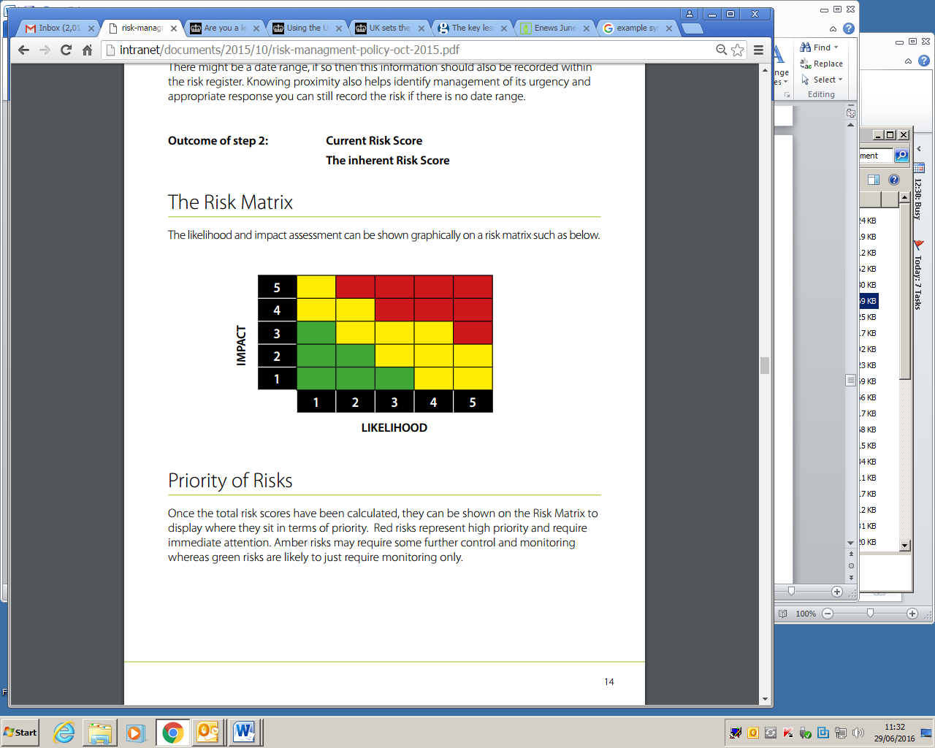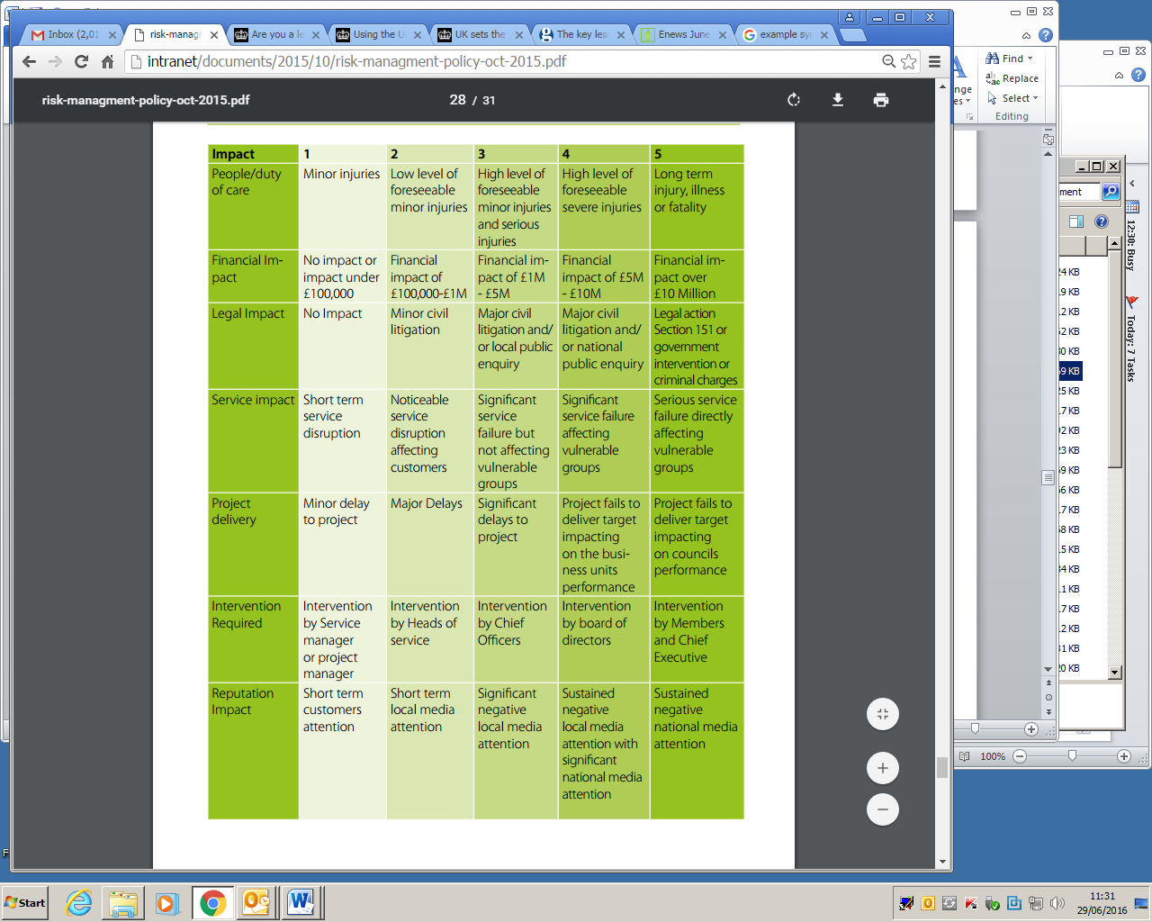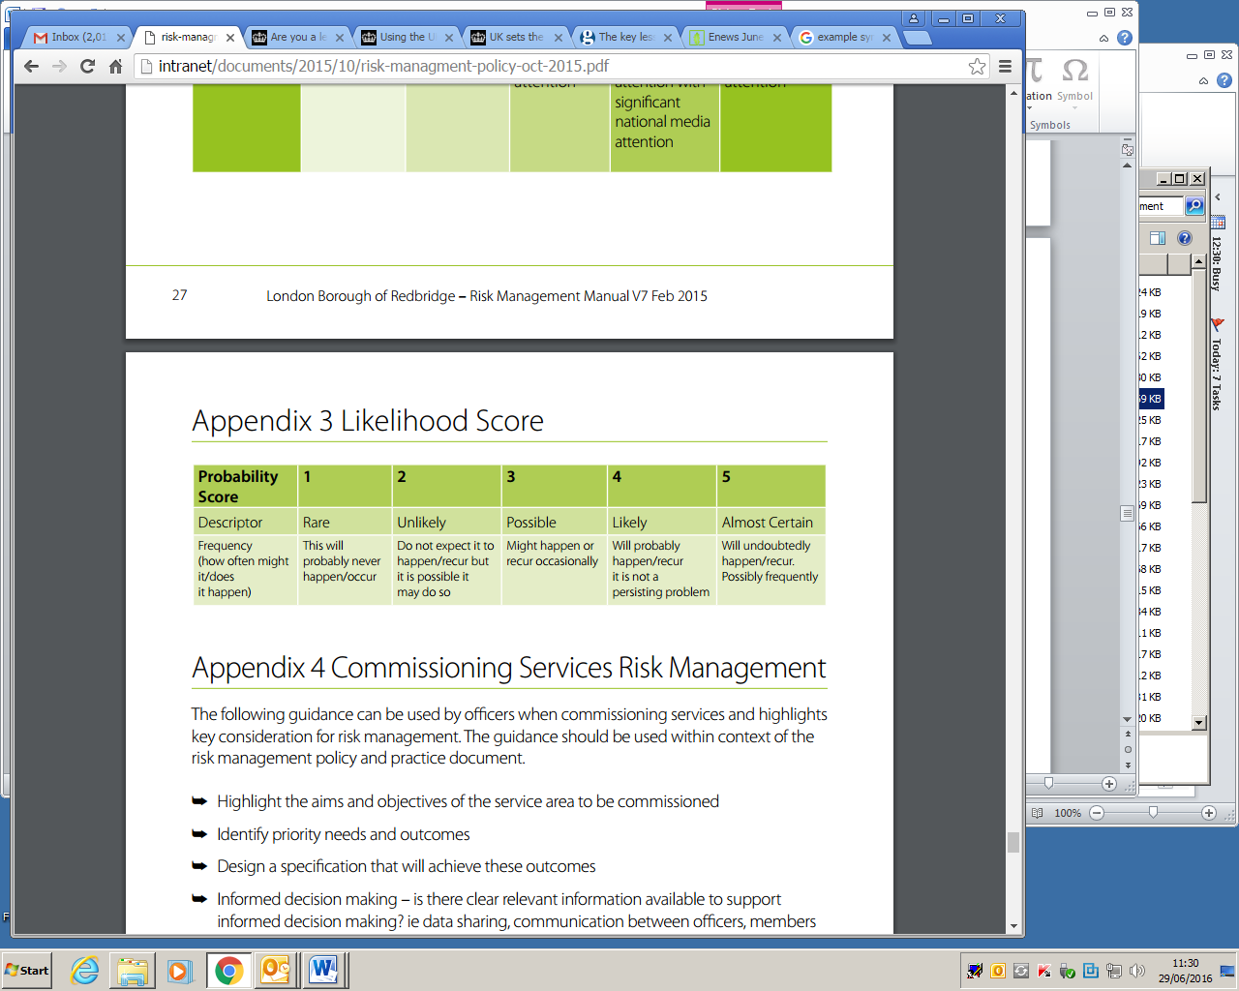

**Service Continuity Plan (for tier one contracts)**

The Cayman Islands Government should ensure that providers of tier one contracted services maintain a business continuity plan for the delivery of those services. The purpose of this template is to provide a draft process for managing major risks to contracted provision and to ensure there won’t be a prolonged disruption to the provision as a result of force majeure or supplier related issues. Not all suggested content will necessarily apply to every contract.

**Introduction**

**Aim of the Plan**

The aim of this plan is to ensure that the core [*goods/ services]* delivered under [*contract name and reference]* can continue to be delivered in the event of an emergency or major and/or prolonged interruption to function and/or supply of key resources and/or infrastructure. The plan should form part of a wider emergency and contingency planning process.

**Key Contractual Functions**

Key functions, which need to be restored under this plan, are listed at Appendix 1.

**Timetable for Resumption of Service**

Required times for the resumption of service are listed at Appendix 1.

**Implementation of the Plan**

## **How is the Plan invoked**

[Consider who invokes the plan and how. Is there a procedure in place for informing staff of an incident?]

## **Key Decision making and Reporting Processes**

[Who makes the decisions and who do they report them too?]

## **Roles and Responsibilities**

[Define the roles of your staff/team in the event of the Plan being instigated.]

# **Response & Recovery**

## **Procedures and processes**

The Risk Assessment (Appendix 2) should be used to identify the route map for delivery of the response and recovery.

## **Command and control**

Decisions regarding implementation of this plan should be taken by [agreed route for contract related decision making, e.g. board etc.] with appropriate authority to decide on any action required and on how this will be communicated.

# 

# **Training & Exercising**

## **Staff Training**

Staff involved will receive suitable training in implementation of the Business Continuity and Contingency Plan as required.

## **Review**

The plan will be maintained and reviewed on an annual basis and as/when required.

**Agreed Key Performance Indicators (KPIs)/KPIs to be managed**

The purpose of this template is to facilitate a clear and common understanding of contractual PIs/KPIs between CIG Ministry and the supplier. This includes clarifications, if required, on what each PI/KPI is measuring and how this data will be collected. This should be agreed between CIG Ministry and the supplier.

|  |  |  |  |  |  |  |  |
| --- | --- | --- | --- | --- | --- | --- | --- |
| **Date of update:** |  | **Contract number:** |  | **Contract name:** |  | **Reviewed by:** |  |

|  |  |  |  |  |  |  |  |
| --- | --- | --- | --- | --- | --- | --- | --- |
| **PI/KPI Ref No** | **PI/KPI Title** | **Frequency**  **(monthly/annual etc)** | **What is being measured** | **Performance Target (quantity/ %)** | **Source of PI/KPI measurement data**  **(what data is used to measure the KPI; who provides it; how it’s validated)** | **Formula used for calculating PI/KPI performance** | **Comments** |
|  |  |  |  |  |  |  |  |
|  |  |  |  |  |  |  |  |
|  |  |  |  |  |  |  |  |
|  |  |  |  |  |  |  |  |
|  |  |  |  |  |  |  |  |

**PI/KPI Tracker**

**The PI/KPI tracker should be used to manage PIs/KPIs performance against reports/MI received from the supplier and related improvement plans for underperforming PI/KPIs.**

|  |  |  |  |  |  |
| --- | --- | --- | --- | --- | --- |
| **Period Covered:** |  | **Contract number:** |  | **Contract name:** |  |

|  |  |  |  |  |  |  |  |  |
| --- | --- | --- | --- | --- | --- | --- | --- | --- |
| **PI/KPI Ref No** | **PI/KPI Detail** | **Date** | **PI/KPI Target Score** | **Score for current measurement period** | **Score for previous measurement period** | **Current month PI/KPI performance**  **(met/not met)** | **Action agreed for underperforming PIs/KPIs** | **Supplier progress report (action/date)** |
|  |  |  |  |  |  |  |  |  |
|  |  |  |  |  |  |  |  |  |
|  |  |  |  |  |  |  |  |  |
|  |  |  |  |  |  |  |  |  |
|  |  |  |  |  |  |  |  |  |

**Default Recovery Plan**

|  |  |  |  |  |  |  |  |  |
| --- | --- | --- | --- | --- | --- | --- | --- | --- |
| **Default Recovery Plan** | | | | | | | | |
| **Contract Name:** | | **Contract Number:** | **Contract Manager (Supplier):** | | **Contract Manager (CIG Ministry):** | | | **Date of Last Update:** |
|  | |  |  | |  | | |  |
| **Activity Number** | **Improvement / Development Activity** | **How the Improvement / Development Activity will be achieved** | **Savings Value ($m)** | **Status** | **Person Responsible** | **Planned Completion Date** | **Actual Completion Date** | **Comments** |
|  |  |  |  |  |  |  |  |  |
|  |  |  |  |  |  |  |  |  |
|  |  |  |  |  |  |  |  |  |
|  |  |  |  |  |  |  |  |  |
|  |  |  |  |  |  |  |  |  |
|  |  |  |  |  |  |  |  |  |

For contracted services where delivery has fallen below acceptable levels, the following is a template for Cayman Islands Government and the supplier to agree and deliver improvement actions to bring the service back up to acceptable levels.

**Site Inspection Template**

|  |  |  |  |
| --- | --- | --- | --- |
| **Contract name:** |  | **Inspected by:** |  |
| **Contract number:** |  | **Date inspected:** |  |

This is an example of the things that officers should be checking for during a site visit. The items to check will be very different if the visit is to a residential care home or to a construction site, and a specific inspection template should be drawn up by the service area for each contract.

|  |  |  |  |  |  |
| --- | --- | --- | --- | --- | --- |
| **Item** | **Condition status** | **Recommended action** | **Timescales for completion** | **Responsible person** | **Comments** |
| **General site survey (maintenance, tidiness, cleanliness etc)** |  |  |  |  |  |
| **Health & Safety records** |  |  |  |  |  |
| **Policies & Procedures, e.g. Equal Opportunities Policy, Quality Assurance** |  |  |  |  |  |
| **Compliance to method statements** |  |  |  |  |  |
| **Hazardous substances** |  |  |  |  |  |
| **First Aid** |  |  |  |  |  |
| **Fire Protection** |  |  |  |  |  |
| **Staff Turnover** |  |  |  |  |  |
| **Information Governance** |  |  |  |  |  |